
Assessment Cover Page
Student Full Name | Ricardo Daniel Cota Valenzuela
Student Number | 2026116
Module Title | Machine Learning for Business
Assessment Title | CA1
Lecturer/Supervisor | Dr. Muhammad Iqbal
Assessment Due Date | 30 Octoberber 2026
Date of Submission | 29 October 2026

Declaration of AI Use — AI Fluency Framework
This assessment applies to CCT College Dublin's AI Fluency Framework — four interconnected competencies that ensure your engagement with AI is effective, efficient, ethical and safe: Delegation, Description, Discernment and Diligence. Full detail on what AI use is permitted for this assessment, and the evidence you must provide, is set out in your Assessment Brief.
Delegation  Setting goals and deciding whether, when and how to engage with AI. | Description  Effectively describing goals to prompt useful AI behaviours and outputs.
Discernment  Accurately assessing the usefulness of AI outputs and behaviours. | Diligence  Taking responsibility for what we do with AI and how we do it.
Adapted from the AI Fluency Framework (Dakan, Feller, Anthropic, 2025).

Filling Out the Cover Sheet
- Fill out the top section of the cover page with all the required information.
- Complete the Student Response column of the AI Declaration table in the appendix of this cover, evidencing your Delegation, Description, Discernment and Diligence.

Appendix: AI Declaration using the AI Fluency Framework
Copy and paste the AI Declaration table from your Assessment Brief HERE. Then follow your lecturers expectations to complete the ‘student response’ section.
AI competence | Reflective prompts (to students) | Lecturer expectations | Student response
Delegation  Deciding whether & when to use AI | Identify the specific tasks in this assessment where you chose to use AI, and explain your reasoning. Where did AI add value? Where did you decide not to use it, and why? | For this assessment, Generative AI may be used only as a supporting tool for brainstorming and refining ideas, fine-tuning research questions, finding relevant information, drafting an outline, checking grammar, clarity and writing style, and other uses explicitly approved by the lecturer. These uses support planning, research and communication. GenAI must not replace the student's own technical implementation, analysis, modelling, evaluation or interpretation, as these directly assess the learning outcomes. You may not copy and paste GenAI output in your submission. All GenAI use must be declared in the GenAI Tools Declaration (Appendix A). Failure to do so is considered to be academic misconduct. | ChatGPT was used to create a flowchart and for translation to improve writing and composition from Spanish to English
Description  How you prompted the AI | Include the exact prompts you used in your appendix (recorded on the AI Tools declaration). Reflect on how you communicated your goals to the AI — did you need to iterate or refine your prompts to get useful output? | Students must provide evidence of prompting for all permitted GenAI use. The exact prompts used, together with relevant links, screenshots or evidence of prompt refinement where applicable, must be provided in Appendix B. Failure to do so is considered to be academic misconduct. | A flowchart was created at the beginning of the project to identify the order of the process and calculate the time for the Assessment. The translation from Spanish to English was done in the introduction and business motivation, dataset source and justification, in the final summary of data preparation, translation from Spanish to English in the results of the charts and in the outcome of the different methods used, and in the conclusion. The evidence is in Appendix B.
Discernment  Evaluating what the AI produced | In your reflection (~100 words), critically evaluate the AI output: what did you accept, modify, or reject — and why? Assess accuracy, relevance, and quality. You are responsible for verifying all AI-generated content before submitting. | A reflection is required for this assessment. In approximately 100 words, students must critically evaluate the accuracy, relevance and quality of any GenAI-assisted outputs, explaining what they accepted, modified or rejected and why. Failure to do so is considered to be academic misconduct. | Google's translation was compared with ChatGPT's translation and writing, noticing better writing with AI
Diligence  Responsibility for your AI use | Declare all AI tools used and cite them here. Briefly outline (~100 words) how you considered data protection, copyright, and ethical responsibilities when choosing what to input into any AI system. Unauthorised use is subject to CCT disciplinary procedures. | Students must declare all GenAI tools used and cite them appropriately. In approximately 100 words, students must explain how they considered data protection, copyright and ethical responsibilities when using GenAI. Unauthorised GenAI use is subject to CCT disciplinary procedures. Failure to do so is considered to be academic misconduct. | ChatGPT
Appendix B: Prompts
Introduction:

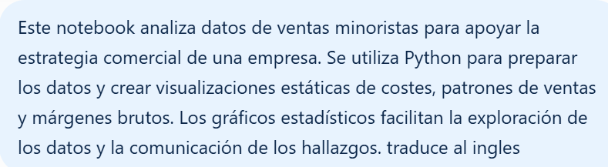
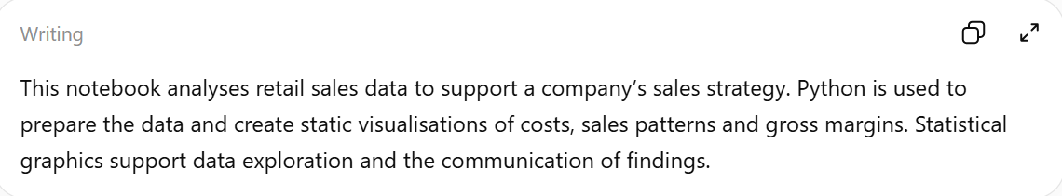
Data Preparation:
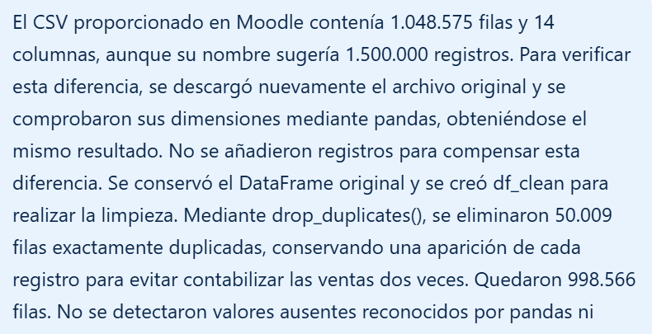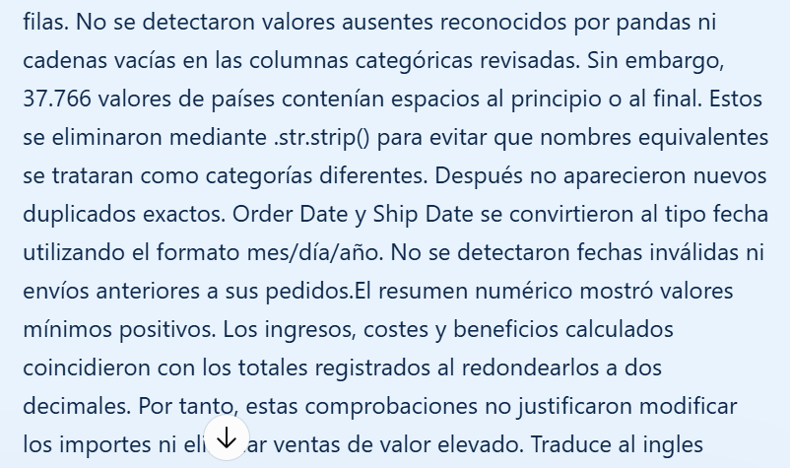

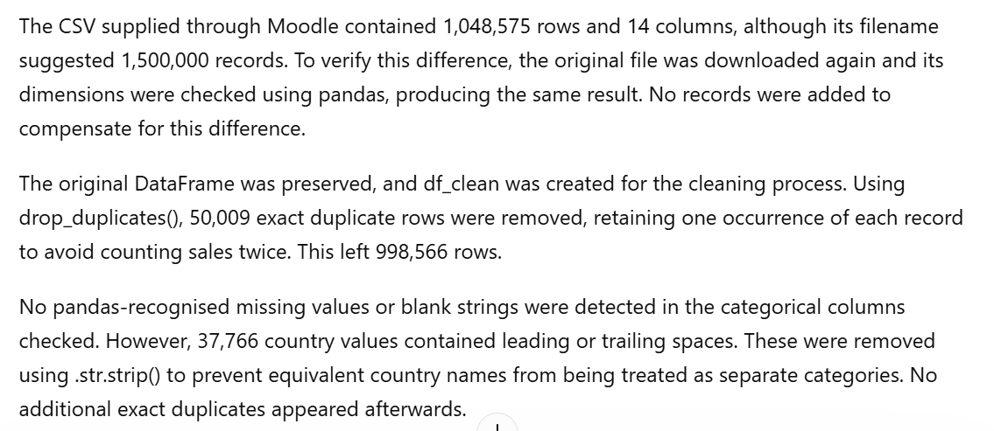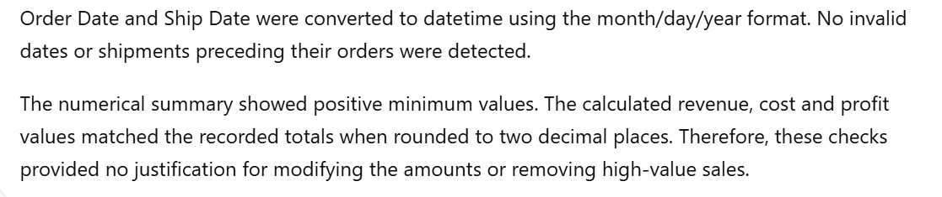

Question 1 to 5:
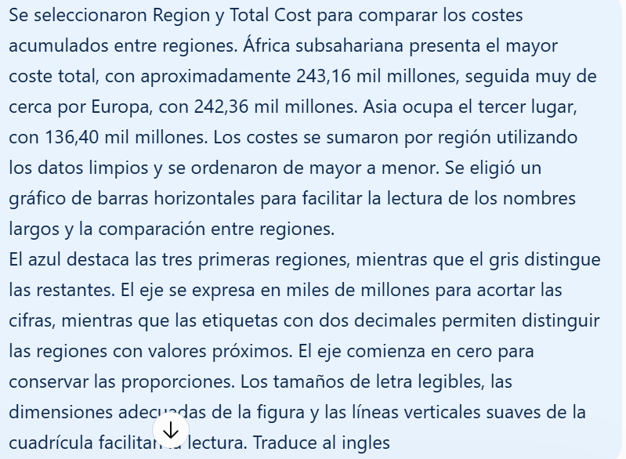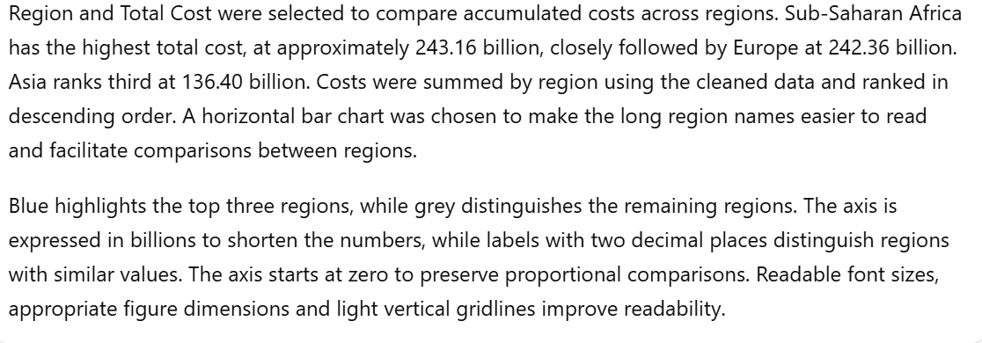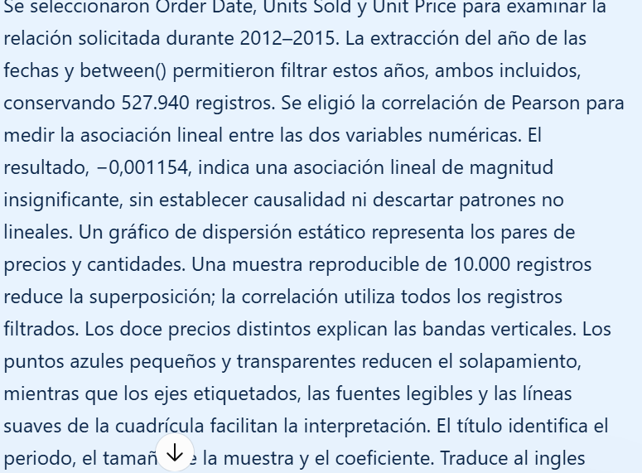
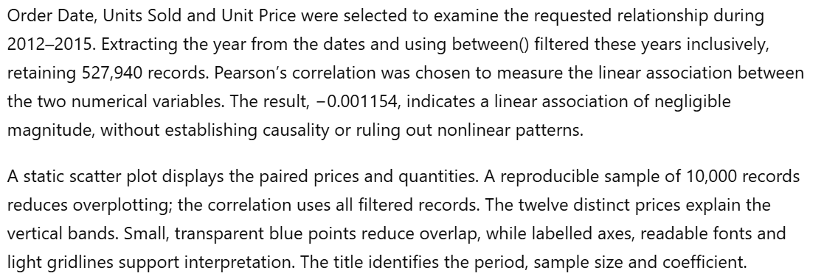
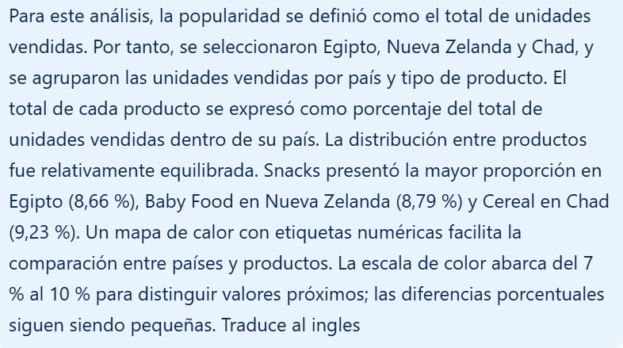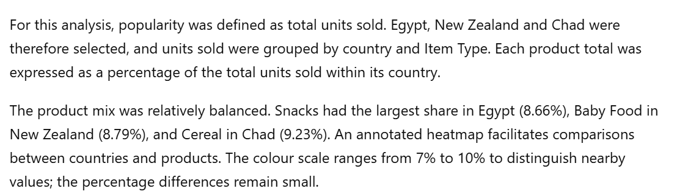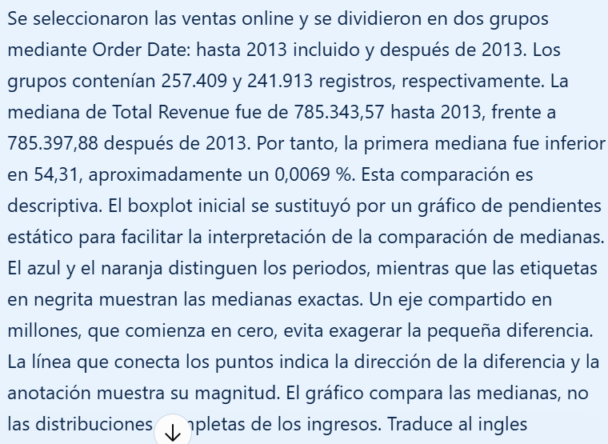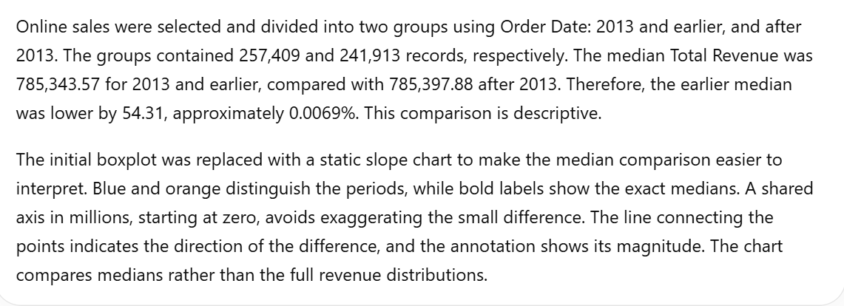

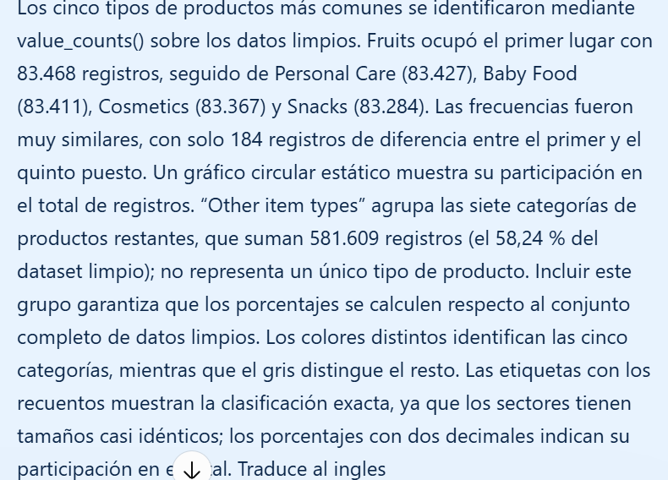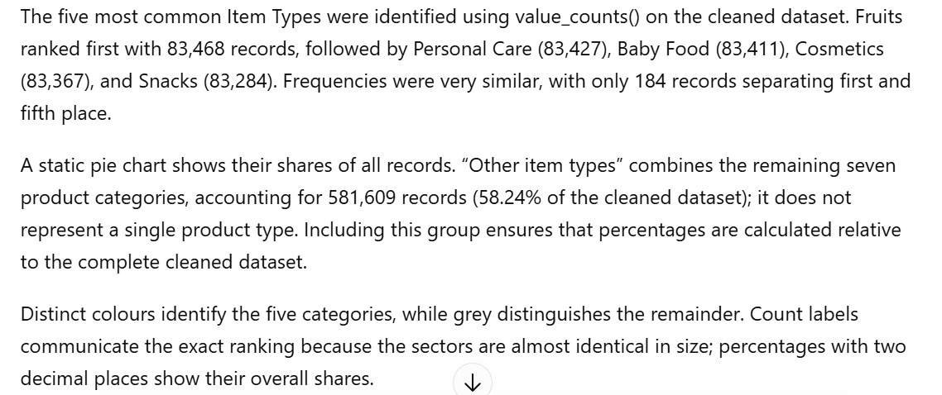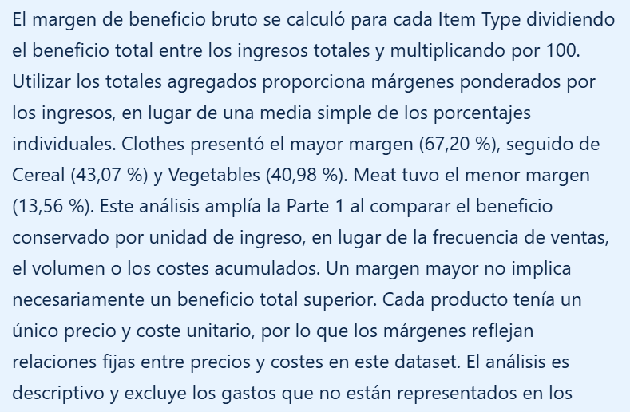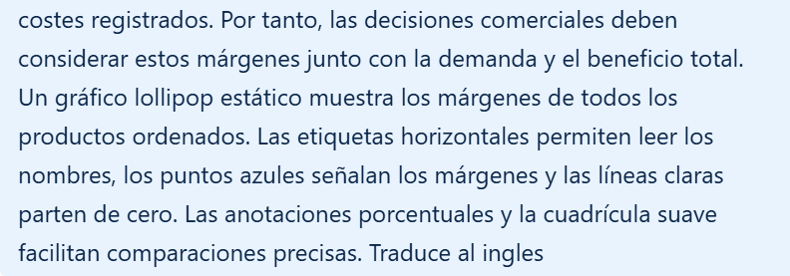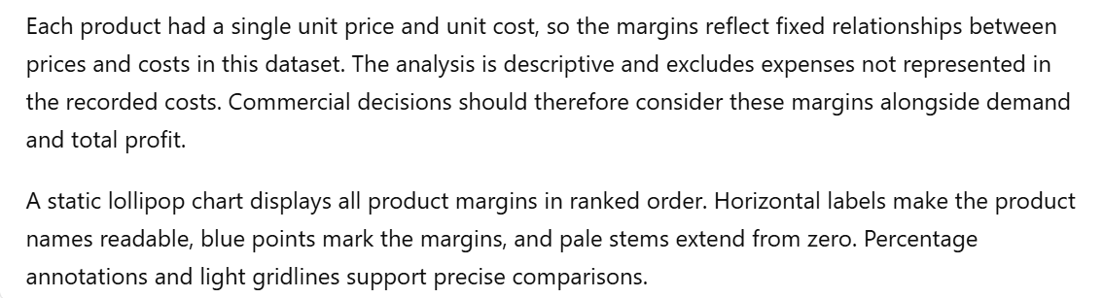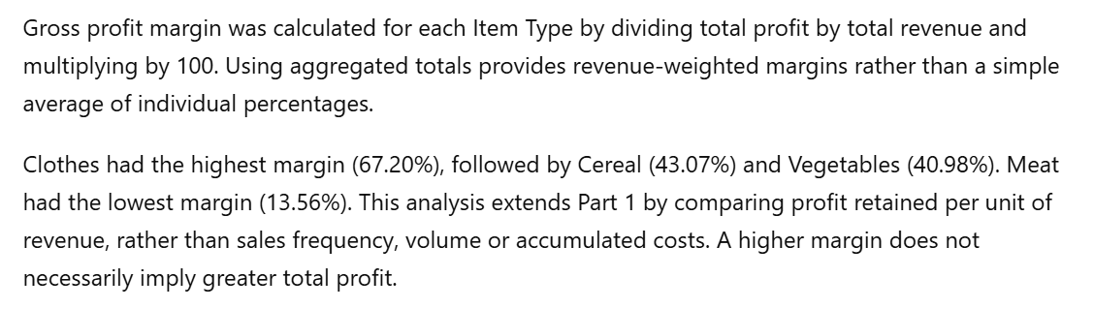
Conclusion:
